The Seventh Habit

Renewal...

Habit 7: Sharpen the Saw

Take time to rejuvenate yourself and help prepare yourself to work better in the future. This often means relaxing, enjoying nature, meditating and praying, reading Scripture or great literature, listening to classical music, and spending time with high-quality relationships.
The purpose of this habit is to regularly exercise the four components which many believe make up the human being: body, mind, heart and spirit.

- Body: Exercise for a sense of well-being.
- Mind: Exercise to sharpen the intellectual abilities.
- Spirit: Exercise with meditations and inner reflections.
- Heart: Exercise care for important relationships.

The fourth category is not an exercise like the others, but rather a commitment to use habits 4, 5 and 6 in everyday life.
Keep positive enthusiasm.

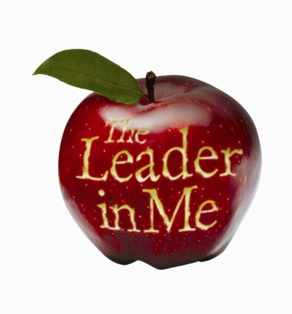

The Seven Habits of Happy Kids…

Habit 1
Be proactive: You’re in Charge

Habit 2
Begin with the End in Mind: Have a Plan

Habit 3
Put First Things First: Work First, Then Play

Habit 4
Think Win-Win: Everyone Can Win

Habit 5
Seek First to Understand, Then to Be Understood: Listen Before You Talk

Habit 6
Synergize: Together is Better

Habit 7
Sharpen the Saw: Balance Feels Best

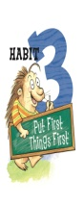
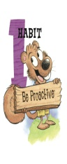
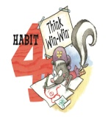
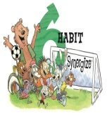
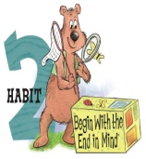
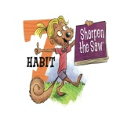

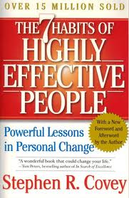

The Seven Habits
Reference for Parents
The 7 Habits...

Private victory, the path to independence...

Habit 1: Be Proactive

Take action and take responsibility. This is the basis of all further habits and a cornerstone of success. You will influence your life more than anyone else. You have the opportunity to use your free will and hard work to change yourself and your circumstances. You are only a victim if you allow yourself to be; if you are reactive rather than proactive. The emphasis of this habit is to do whatever is in your power to improve your situation. You are the creator, the actor and the doer in your life; get started and "just do it". Since, in a situation, the thing that you can influence and change the most is your response to it choose your response to any situation and you will find yourself in control. No one can "make" you angry if you decide you don't want to get angry. Don't let life set you up in a bad situation. Have confidence in yourself and believe that you can succeed in anything in life.

Habit 2: Begin With the End in Mind

Visualize where you want to go. Before you start something sit down and plan it out. A little planning will usually save you a lot of actual work later. Use your creative forces to create images and plans in your head first, then carry out your plan. The plan is called the first creation; the second creation is formed when you carry out the plan, and its success depends on a well thought out first creation.

Habit 3: Put First Things First

Set priorities. Decide which of your values and goals are most important, then determine what steps will best achieve those goals. Basically it means doing life with your values in hand. It means defining your idea of success in life from the image you would like to leave in the roles that you assume like spouse, grandparent, voter, activist. The idea is to have these clearly defined and on a piece of paper.

Public victory, the path to interdependence...

Habit 4: Think Win-Win

Many people grow up with a competitive mindset ("I win, you lose"), a beaten-down mindset ("I give up, do what you want to me"), or a mix of these and other mindsets. Each of these has its place. However, for your most valuable family and business interactions, the most mature and effective goal is usually to seek situations which benefit everyone involved.
When you negotiate you should seek to make deals that help everyone. In cases where this is not possible, it is best to have the mindset from the outset that you will walk away from the deal ("win-win or no deal").

Habit 5: Seek First to Understand , Then to be Understood

To influence and help others, you must first actively listen to them and understand their situation and concerns. For example, imagine a doctor who gives a prescription over the telephone with-out knowing all the necessary information about the patient and their condition. This could be a serious or even fatal error if the patient takes the wrong medicine. In the same way, when giving someone advice we should be quite careful to understand their circumstances well. Even excellent advice can be useless and wasted if it does not apply to the situation of the person receiving it.

It is most effective to listen actively and empathetically, consciously trying to understand and to see the world from the other person's perspective. It is also beneficial to listen without judging. Avoid "hearing" through a filter formed by your own worldview, and do not impose your preconceived ideas on what you hear, because doing so will inhibit your efforts to put yourself in the other person's shoes.

Habit 6: Synergize

This habit deals with teamwork and opening yourself emotionally to work with other people. Optimistic, emotionally charged individuals who are living out the previous habits can work together in amazing ways and see new paths none of them would have found alone. One plus one is three, or more, when these "third alternatives" appear. This synergy is a bit chaotic but is also fun and stimulating. When you use synergy you are also improving your spiritual, emotional and social side of your life.

